Supplementary Data

Table of Contents

- Background Initial Set Construction
- Background training set construction (Common Background)
- Test Group
- Background Quantification
  - IGF2BP1
  - IGF2BP3
  - PUM2
  - HuR
  - YTH
  - AUF1
  - MOV10
  - CF_Im25
  - QKI
- References

- Background Initial Set Construction

We refer to the background set as the set of reads reproducible between PAR-CLIP libraries, these reads regularly are identical between different PAR-CLIP analysis, experiments and laboratories.
The background set construction begins with the sequencing libraries (Table S1) derivate of stained and discrete background bands identified in PAR-CLIP analysis (Friedersdorf and Keene, 2014). These bands called in relation their size: 45 Kda, 35 Kda and 20 Kda (referred to as G45, G35 and G20). Friedersdorf and Keene (2014), use PARalyzer (Corcoran et al. 2010) and obtain the clusters of reads and two sets of output files. They defined PARalyzer groups as sites with any read evidence and clusters as sites with at least 2 T-to-C conversion locations and at least 5 overlapping reads. In the background set construction, we used the groups obtained with PARalyzer.

Table S1. Number of clusters in each Background Initial Sets.

Background Size Parameter | Number of Clusters
PARbkg.G20 | 706884
PARbkg.G35 | 259338
PARbkg.G45 | 379719

We used Pybedtools (Dale et al. 2010) (Quinlan and Hall, 2010) to find the intersection between the background Initial Sets (Table S1). In this way, we identified common sites, and we were able to remove duplicates (Figure S1). We assigned a score to each site in the dataset reflecting the number of datasets that contain such site. We built a set named Global Background Groups (GLOBALBACKGROUNDGROUPS.bed) that contains all the sites present in the background initial sets, each cluster has a score between 1 and 3.

Figure S1: Background Initial Sets.

G20
706884

G45
379719
G35
259338

79567

51429

104700
73405

In order to avoid any bias, we used a Background training set with proteins not present in the test group.

- Background training set construction (Common Background)

We randomly selected seven proteins and used the corresponding datasets (19 in total) (Table S2) to build a Background Training Set. In this case, for each dataset we used the PARalyzer group output file reported by Friedersdorf and Keene (2014). In figure S2, we present the workflow used to build the background training set.

Table S2. Datasets used to build the Background Training Set Construction

Protein | Dataset | Number of Clusters | Reference PMID | Reference | Cell Type
AGO2  Argonaute-2 | SRR592685 | 47800 | 22291592 | (Skalsky et al., 2012) | Lymphoblastoid Cell
AGO2  Argonaute-2 | SRR592686 | 28078 | 22291592 | (Skalsky et al., 2012) | Lymphoblastoid Cell
AGO2  Argonaute-2 | SRR592687 | 3033 | 22291592 | (Skalsky et al., 2012) | Lymphoblastoid Cell
AGO2  Argonaute-2 | SRR592688 | 2914 | 22291592 | (Skalsky et al., 2012) | Lymphoblastoid Cell
AGO2  Argonaute-2 | SRR592689 | 18234 | 22291592 | (Skalsky et al., 2012) | Lymphoblastoid Cell
AGO2  Argonaute-2 | SRR048974 | 11690 | 20371350 | (Hafner et al., 2010) | Lymphoblastoid Cell
AGO2  Argonaute-2 | SRR048975 | 19694 | 20371350 | (Hafner et al., 2010) | Human Embryonic  Kidney 293 cells
IGF2BP2  Insulin-like growth factor 2 mRNA-binding protein 2 | SRR048957 | 428371 | 20371350 | (Hafner et al., 2010) | Human Embryonic  Kidney 293 cells
IGF2BP2  Insulin-like growth factor 2 mRNA-binding protein 2 | SRR048958 | 31153 | 20371350 | (Hafner et al., 2010) | Human Embryonic  Kidney 293 cells
ALKBH5  RNA demethylase ALKBH5 | SRR500478 | 29540 | 22681889 | (Baltz et al., 2012) | Human Embryonic  Kidney 293 cells
ALKBH5  RNA demethylase ALKBH5 | SRR500479 | 30431 | 22681889 | (Baltz et al., 2012) | Human Embryonic  Kidney 293 cells
C17orf85  Uncharacterized protein C17orf85 | SRR500480 | 5352 | 22681889 | (Baltz et al., 2012) | Human Embryonic  Kidney 293 cells
C17orf85  Uncharacterized protein C17orf85 | SRR500481 | 12115 | 22681889 | (Baltz et al., 2012) | Human Embryonic  Kidney 293 cells
C22orf28  tRNA-splicing ligase RtcB homolog | SRR500482 | 179922 | 22681889 | (Baltz et al., 2012) | Human Embryonic  Kidney 293 cells
C22orf28  tRNA-splicing ligase RtcB homolog | SRR500483 | 83285 | 22681889 | (Baltz et al., 2012) | Human Embryonic  Kidney 293 cells
CAPRIN1  Caprin-1 | SRR500484 | 49653 | 22681889 | (Baltz et al., 2012) | Human Embryonic  Kidney 293 cells
CAPRIN1  Caprin-1 | SRR500485 | 356088 | 22681889 | (Baltz et al., 2012) | Human Embryonic  Kidney 293 cells
FMR1  Fragile X mental retardation protein 1 | SRR527727 | 1148674 | 23235829 | (Ascano et al., 2012) | Human Embryonic  Kidney 293 cells
FMR1  Fragile X mental retardation protein 1 | SRR527730 | 757638 | 23235829 | (Ascano et al., 2012) | Human Embryonic  Kidney 293 cells

Figure S2: Workflow to build the Common Background Set
∩
Common Background - Training set (BackgroundTraining_19datasets.bed) changes at each recirculation. Initially is the Background Initial set

Group file for each dataset (e.g. AGO2.rep1.groups.bed)

Increase score

Remove duplicates and Merge reads in the same position, leaving the occurrence with the maximum score

Recirculation for each dataset

Remove short reads
(Length less than 10)

The Common Background is modified for the next circulation
(BackgroundTraining_19datasets.bed)

At the end of the process, the BackgroundTraining_19datasets.bed is the result of 19 Datasets analyzed. In Figure S3 shows the distribution of the score in the Common Background (Training Groups).

Figure S3: Scores Distribution for the Common Background (Training Group)

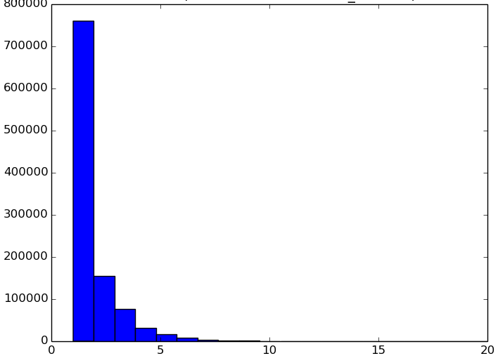

Score

- Test Group

We use nine proteins and the corresponding 30 datasets (See Table S3). We downloaded the datasets from the Gene Expression Omnibus (http://www.ncbi.nlm.nih.gov/geo/). Once we downloaded the datasets, we used the SRA toolkit to convert the SRA files into Fastq files. Consequently, we aligned the datasets separately with two programs TopHat (Trapnell et al., 2009) and Bowtie (Langmead et al., 2009). We used the hg19 genome reference index.

In figure S3, We present the workflow used to test the background set. We used the program Cluster Detection (https://github.com/phrh/BackCLIP) to identify the clusters present in each dataset.

Table S3: Datasets in the Test group

Analyzed Protein | Dataset | Cluster |  | Reference GEO | Reference PMID | Reference | Cell Type
Analyzed Protein | Dataset | Bowtie | TopHat
IGF2BP1  Insulin-like growth factor 2 mRNA-binding protein 1 | SRR048950 | 828 | 882 | GSE21918 | 20371350 | (Hafner et al., 2010) | HEK 293  Cells
IGF2BP1  Insulin-like growth factor 2 mRNA-binding protein 1 | SRR048951 | 28620 | 38052
IGF2BP1  Insulin-like growth factor 2 mRNA-binding protein 1 | SRR048952 | 31561 | 42574
IGF2BP1  Insulin-like growth factor 2 mRNA-binding protein 1 | SRR048953 | 4760 | 6617
IGF2BP1  Insulin-like growth factor 2 mRNA-binding protein 1 | SRR048954 | 5464 | 7357
IGF2BP1  Insulin-like growth factor 2 mRNA-binding protein 1 | SRR048955 | 206 | 297
IGF2BP3  Insulin-like growth factor 2 mRNA-binding protein 3 | SRR048962 | 2438 | 214
IGF2BP3  Insulin-like growth factor 2 mRNA-binding protein 3 | SRR048963 | 73307 | 13881
IGF2BP3  Insulin-like growth factor 2 mRNA-binding protein 3 | SRR048964 | 34932 | 9688
IGF2BP3  Insulin-like growth factor 2 mRNA-binding protein 3 | SRR048965 | 8386 | 3812
IGF2BP3  Insulin-like growth factor 2 mRNA-binding protein 3 | SRR048966 | 10583 | 2209
PUM2  Pumilio | SRR048967 | 9150 | 1167
PUM2  Pumilio | SRR048968 | 2820 | 340
QKI  Quaking | SRR048969 | 5286 | 594
QKI  Quaking | SRR048970 | 5091 | 547
QKI  Quaking | SRR048971 | 1688 | 429
QKI  Quaking | SRR048972 | 590 | 131
HuR  ELAV-like protein 1 | SRR309285 | 1385 | 91 | GSE29943 | 21723171 | (Lebedeva et al., 2011) | HeLa cells
HuR  ELAV-like protein 1 | SRR309286 | 2217 | 183
HuR  ELAV-like protein 1 | SRR189777 | 111972 | 5055 | GSE28865 | 21572407 | (Kishore et al., 2011) | HEK 293  Cells
HuR  ELAV-like protein 1 | SRR189778 | 86050 | 3913
YTHDC1  YTH domain-containing protein 1 | SRR1373360 | 60371 | Not Available | GSE58352 | 25242552 | (Xu et al., 2014) | HeLa cells
YTHDC1  YTH domain-containing protein 1 | SRR1373361 | 70451 | Not Available
MOV10  Putative helicase MOV-10 | SRR490650 | 37366 | 6428 | GSE37524 | 22844102 | (Sievers et al., 2012) | HEK 293  Cells
AUF1  Heterogeneous nuclear ribonucleoprotein D0 | SRR1042839 | 964 | 106 | GSE52971 | 25366541 | (Yoon et al., 2014) | HEK 293  Cells
AUF1  Heterogeneous nuclear ribonucleoprotein D0 | SRR1042840 | 2769 | 257
AUF1  Heterogeneous nuclear ribonucleoprotein D0 | SRR1042841 | 2681 | 186
AUF1  Heterogeneous nuclear ribonucleoprotein D0 | SRR1042842 | 1896 | 129
CF_Im25  Cleavage and polyadenylation specificity factor subunit 5 | SRR488725 | 51198 | 39443 | GSE37398 | 22813749 | (Martin et al., 2012) | HEK 293  Cells
 | SRR488726 | 15410 | 9688

Figure S3: Alignment Workflow for Each Dataset

Dataset (e.g. SRR048950.fastq)
Bowtie Alignment to Genome Genome
Tophat Alignment to Genome

Hg19 Genome

Reads Aligned
(Output in Sam format)

Cluster Detection

Sam Input File
Minimum Occurrences = 5
Minimum Read length=20
Alignment to hg19 genome
Filtered by
Presence of SNPs
Entropy
All Mutation

Clusters_filtered.bed
Clusters_filtered.txt (With sequence and reads)

- Background Quantification

To quantify the background presence in each dataset, we obtained the intersection between the Background Training Set (GLOBALBACKGROUNDGROUPS.bed.sorted.delete.min10) and the output of ClusterDetection. Next, we filter the short reads and keep the sequence reads with a minimum length of ten bases. As a result, we have the clusters that intersect with the background and the corresponding score. In Table S4, we provide (1) a number of clusters and, (2) percentage of clusters present in the intersection of Background.

In order to validate the presence of the background in a specific dataset, we observed in detail three scenarios:
(1) The distribution of the score in the intersection with the background
(2) Presence of the specific motif in all the clusters and the clusters present in the intersection. In the next section, we present a complete analysis of each protein in the test group.

4.1. IGF2BP1 (Insulin-like growth factor 2 mRNA-binding protein 1)

This protein is a member of the insulin-like growth factor 2 mRNA-binding protein family. IGF2BP1 contains four K-homology domains and two RNA recognition motifs. Its principal function is to bind genes (insulin-like growth factor 2, beta-actin and beta-transducing) to promote and regulate translation (Hafner et al., 2010; Nielsen et al., 1999). Hafner et al. (2010) reported six PAR-CLIP datasets for this protein (Table S4) and the motif CAUH reported. We quantified the presence of the motif in each data set.

We present the boxplot and the histogram for the intersection scores in Fig S4 and Fig S5. In addition, we provide the confidence interval for the mean distribution in Table S4. We define a threshold for the score equal to 10, which is half the maximum score in the training set. We use this score to make inferences.

Table S4: Background Quantification for IGF2BP1 protein

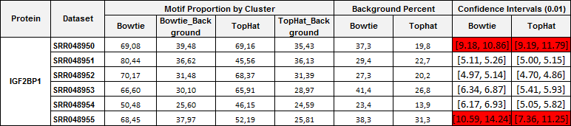

Figure S4: Boxplot for the scores in the intersection between the common background and six IGF2BP1 PAR-CLIP datasets.
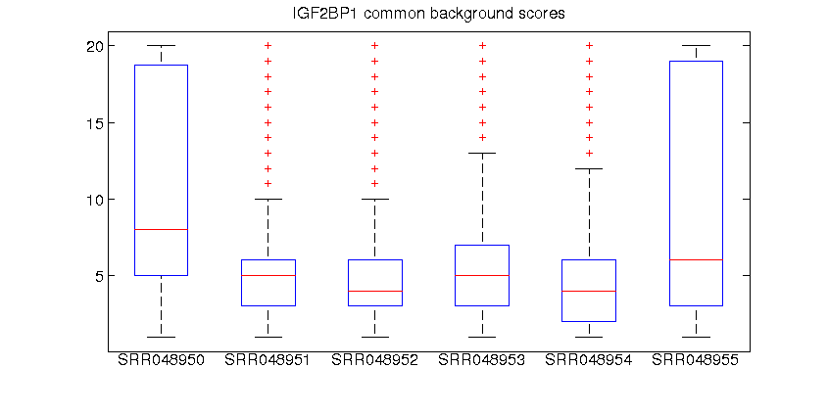

Figure S5: Histogram for scores in the intersection between the common background and six IGF2BP1 PAR-CLIP datasets (aligned with Bowtie and Tophat)

 | Bowtie | Tophat
SRR048950 | 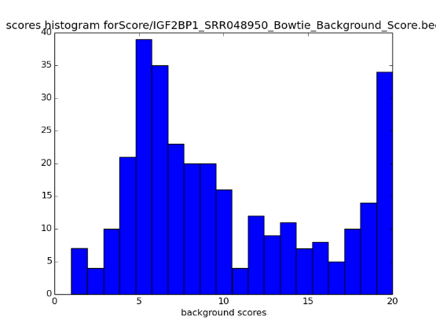 | 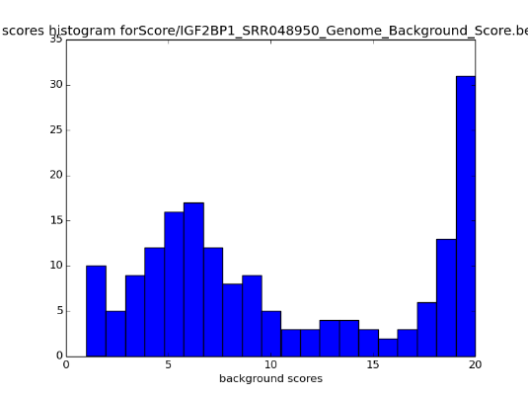
SRR048951 | 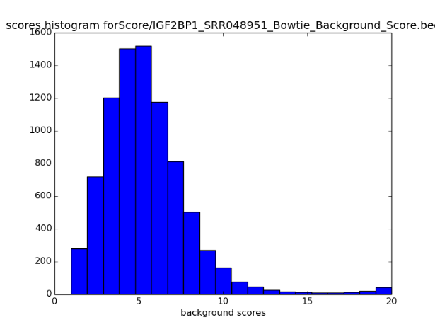 | 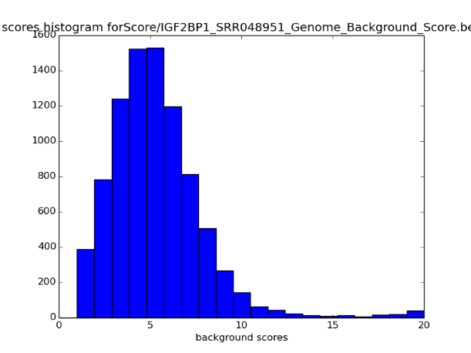
SRR048952 | 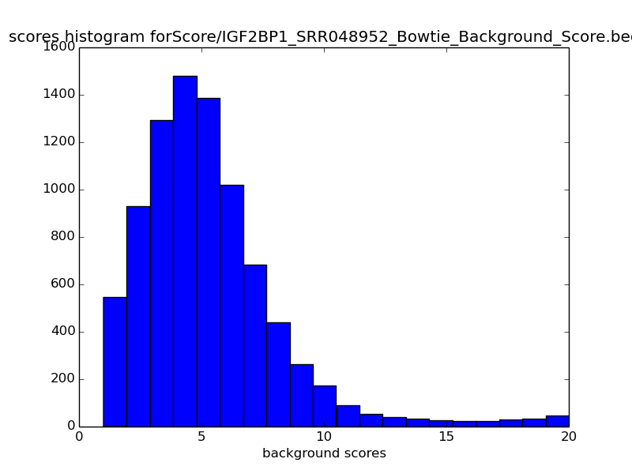 | 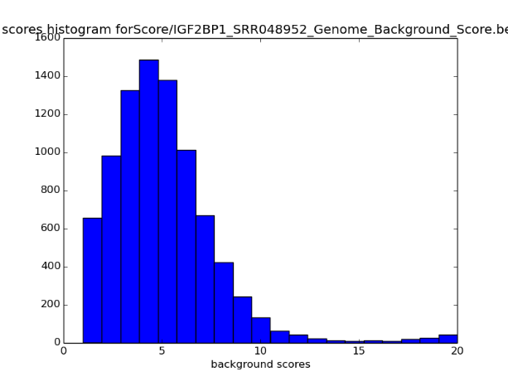
SRR048953 | 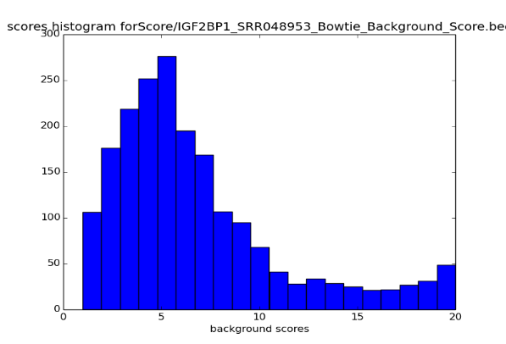 | 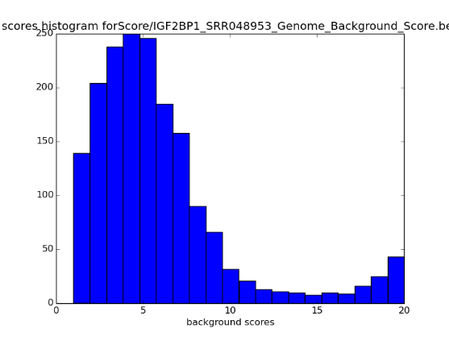
SRR048954 | 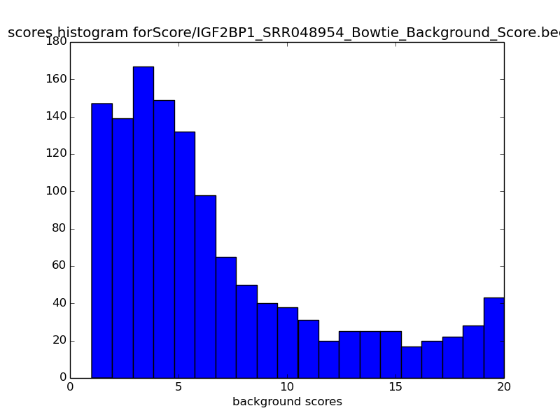 | 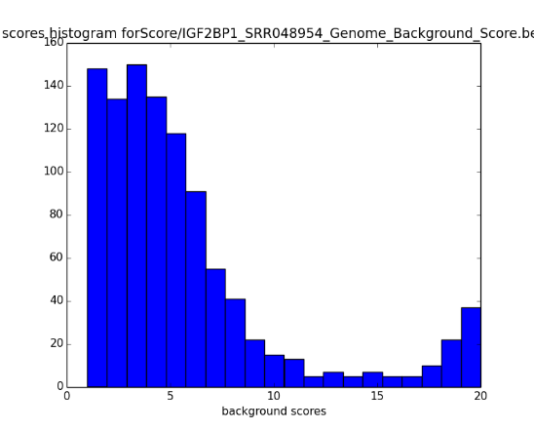
SRR048955 | 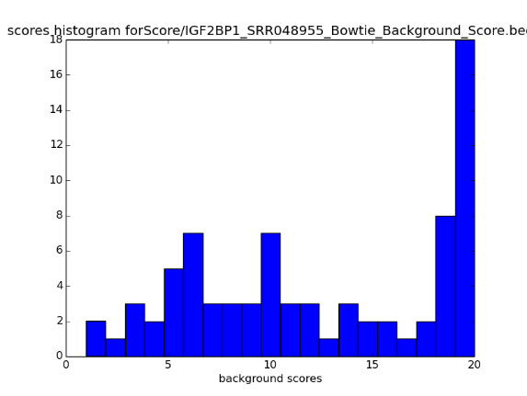 | 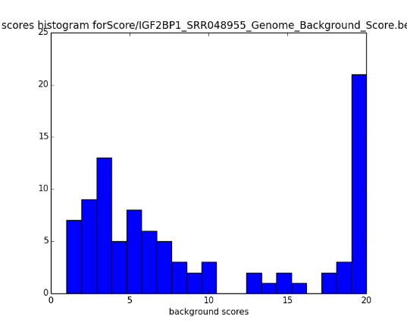

In particular, we observe the datasets SRR048950 and SRR048955 have a notable presence of background. The histograms, for these two datasets, have a high number of sites with a high score, differently from the other datasets (SRR048951, SRR048952, SRR048953, and SRR048954). The confidence interval for the mean for these two datasets is higher than half of the maximum score.

4.2. IGF2BP3 (Insulin-like growth factor 2 mRNA-binding protein 3)

RNA binding protein member of the insulin-like growth factor 2. It may recruit target transcripts to cytoplasmic protein-RNA complexes and promotes mRNA transport and transient storage. It also is involves in the microRNA-mediated degradation. (Hafner et al., 2010; Nielsen et al., 1999). Five datasets were reported for IGF2BP3 (Table S5) protein and together with all member of the IGF2BP family shares the CAUH motif.

We quantified the presence of the motif in each data set. We present the boxplot and the histogram for the intersection scores in Fig S6 and Fig S7. In addition, we provide the confidence interval for the mean distribution in Table S5. We define a threshold for the score equal to 10, which is half the maximum score in the training set. We use this score to make inferences.

Table S5: Background Quantification for IGF2BP3 protein

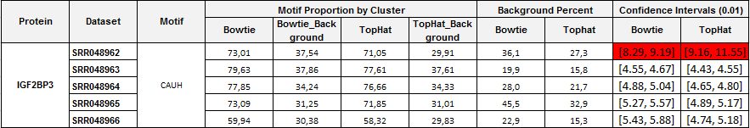

Figure S6: Boxplot for the scores in the intersection between the common background and five IGF2BP3 PAR-CLIP datasets.

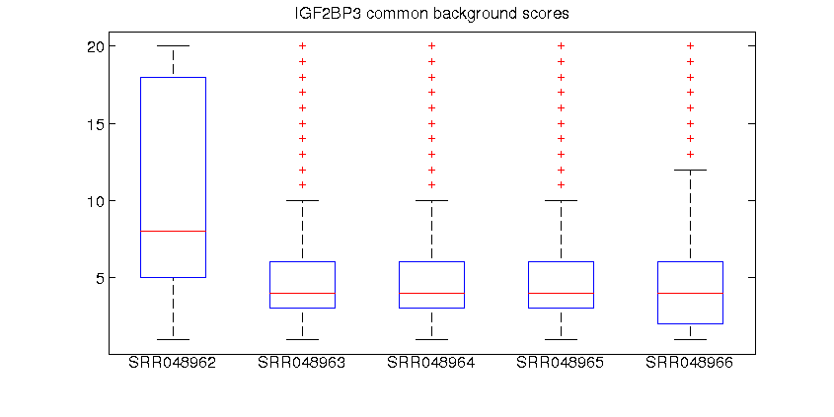

Figure S7: Histogram for scores in the intersection between the common background and fiveIGF2BP3 PAR-CLIP datasets (aligned with Bowtie and Tophat)

 | Bowtie | Tophat
SRR048962 | 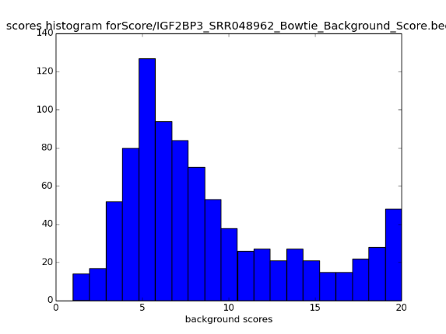 | 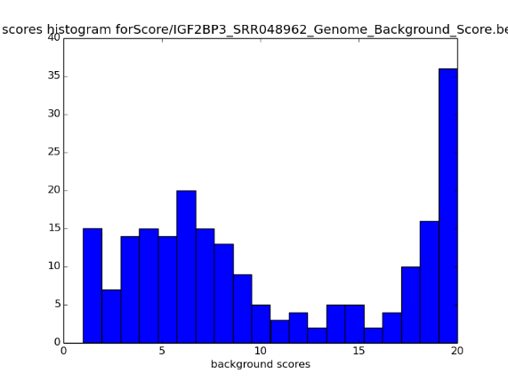
SRR048963 | 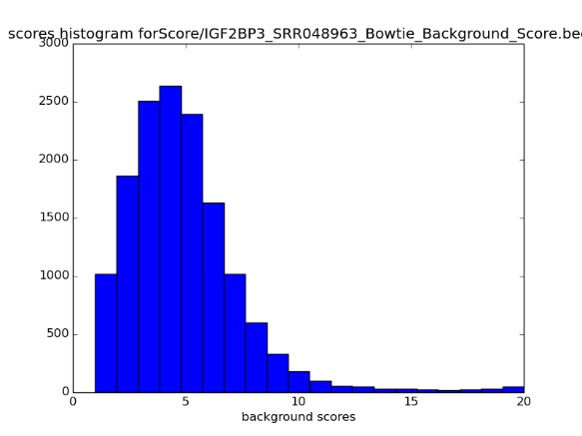 | 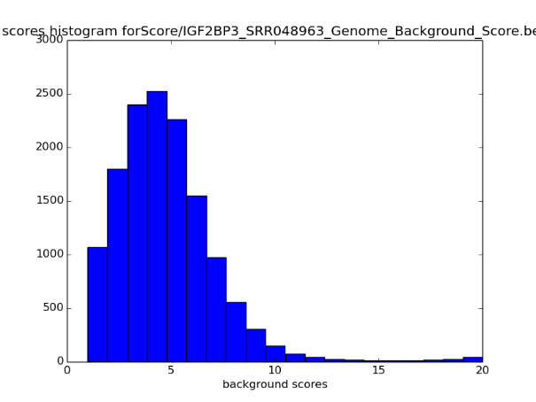
SRR048964 | 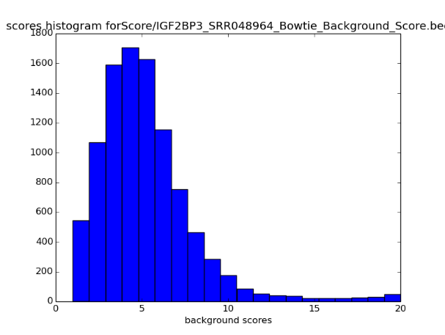 | 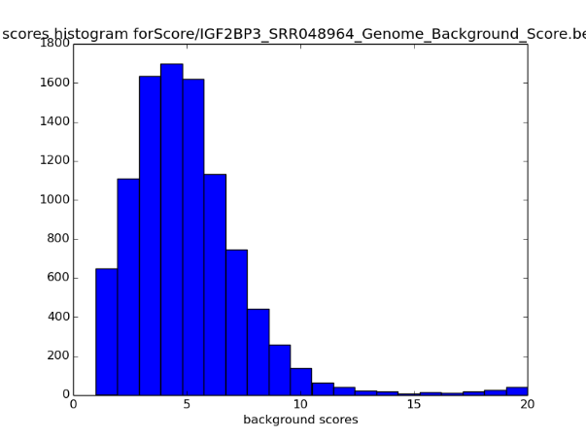
SRR048965 | 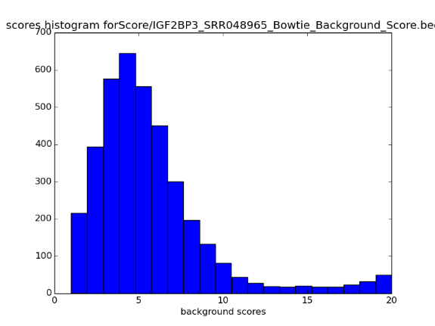 | 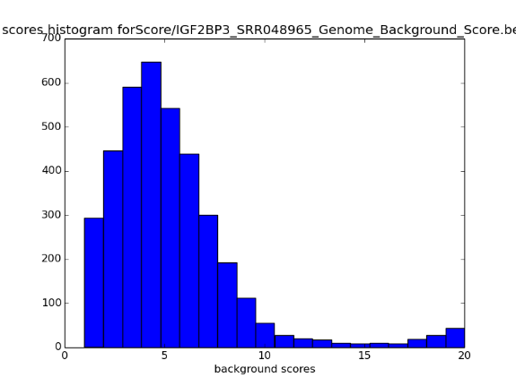
SRR048966 | 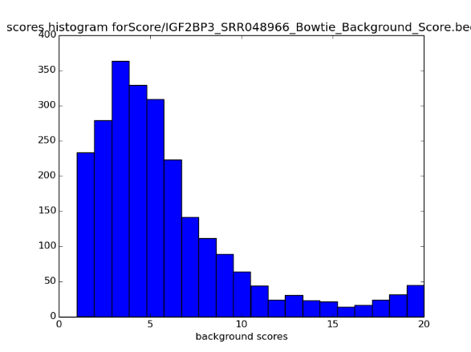 | 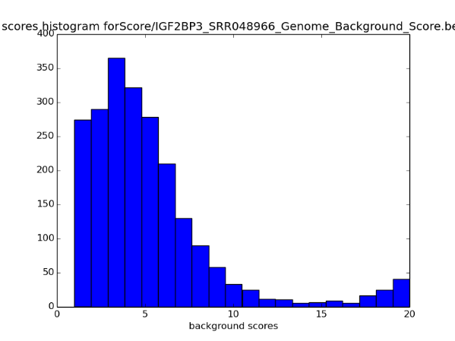

For this protein, the dataset SRR048962 has a significant amount of common background.

4.3. PUM2 (Pumilio)

PUM2 is an RNA-binding protein that negatively regulates translation and stability of mRNA by binding the 3'-UTR of mRNA targets. PUM2 recognizes the motif UGUANAUA. PUM2 is involved in the proliferation and self-renewal of stem cells by regulating the translation of key transcripts (Hafner et al., 2010; Moore et al., 2003). For PUM2, two datasets were indexed in GEO Bank (Table S6), and the distribution of the score is shown in Fig S8.

Table S6: Background Quantification for PUM2 protein
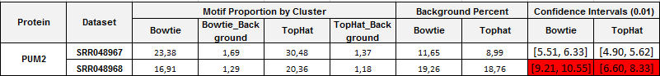

Figure S8: Boxplot for the scores in the intersection between the common background and two PUM2 PAR-CLIP datasets.
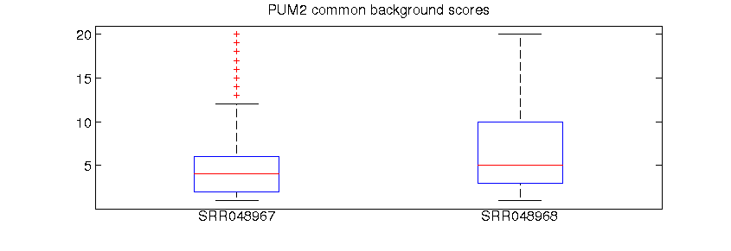

Figure S9: Histogram for scores in the intersection between the common background and two PUM2 PAR-CLIP datasets (aligned with Bowtie and Tophat)

 | Bowtie | Tophat
SRR048967 | 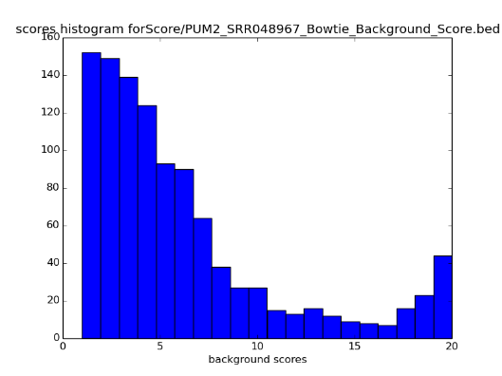 | 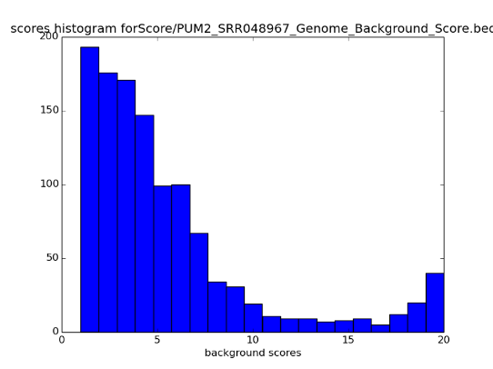
SRR048968 | 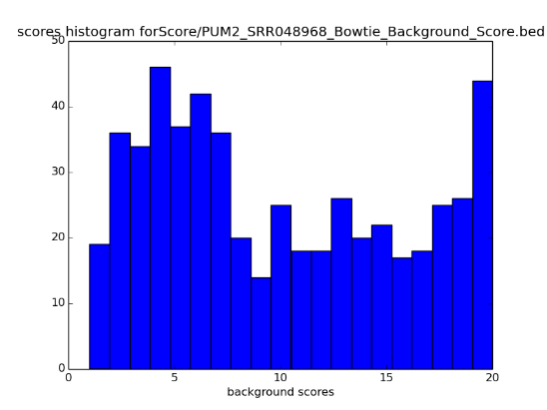 | 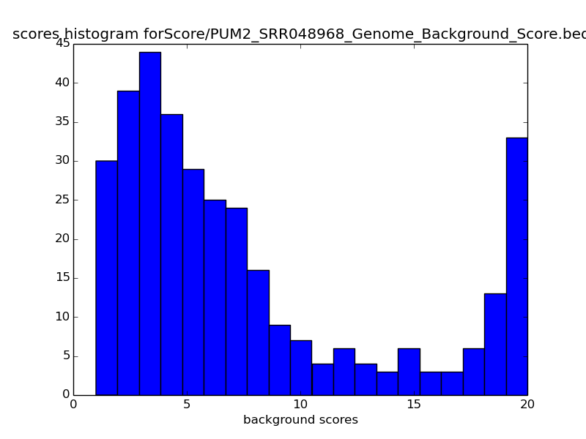

For this protein, the dataset SRR048968 has a significant amount of common background, both histogram, and the mean confidence interval show that most of the intersection scores are higher than 10.

4.4. HuR (ELAV-like protein 1)

HuR is involved in embryonic stem cells (ESCs) differentiation. Mainly binds to poly-U elements and AU-rich elements (AREs) in the 3'-UTR of target mRNAs (Kishore et al., 2011; Lebedeva et al., 2011; Ma et al., 1996). We used datasets (Table S7) published by Kishore (SRR189777 and SRR189778) and Lebedeva (SRR309285 and SRR309286). The recognition motif is the poly-U elements UUUNUU.

Table S7: Background Quantification for HuR protein
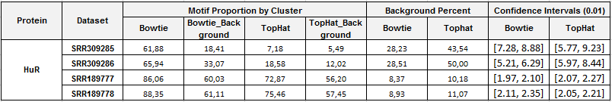

Figure S10: Boxplot for the scores in the intersection between the common background and two HuR PAR-CLIP datasets.
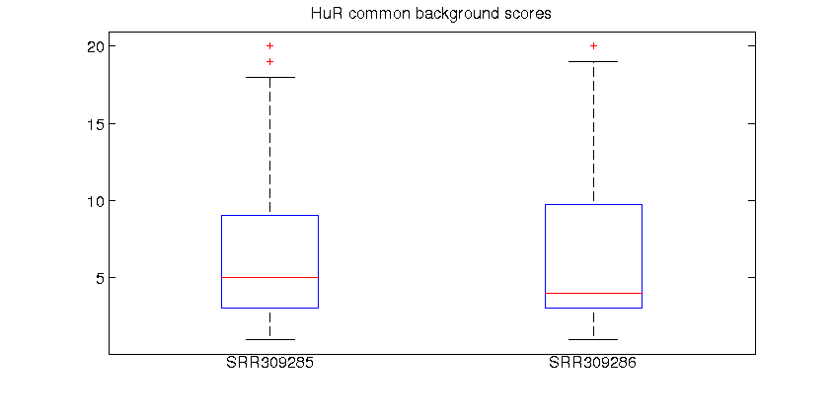

Figure S11: Histogram for scores in the intersection between the common background and four HuR PAR-CLIP datasets (aligned with Bowtie and Tophat)

 | Bowtie | Tophat
SRR189777 | 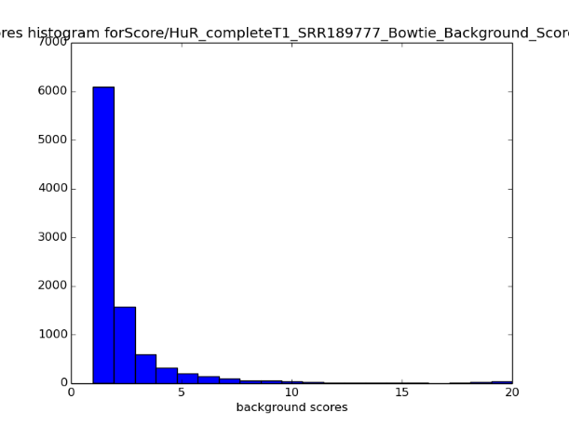 | 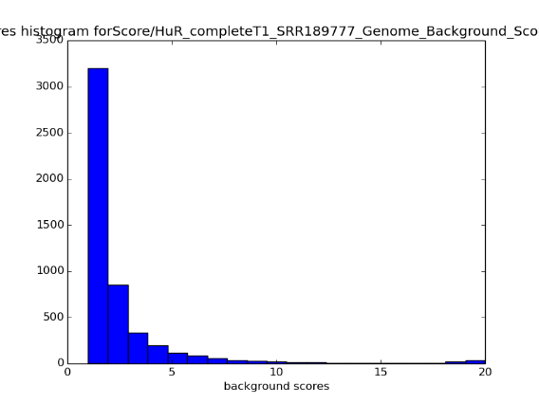
SRR189778 | 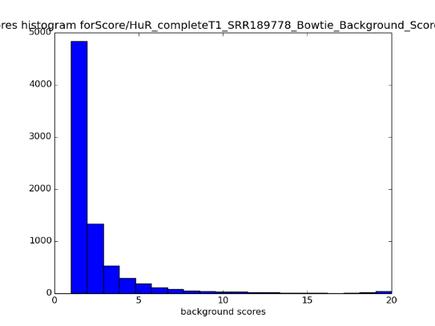 | 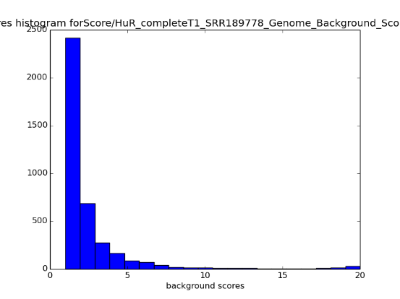
SRR309285 | 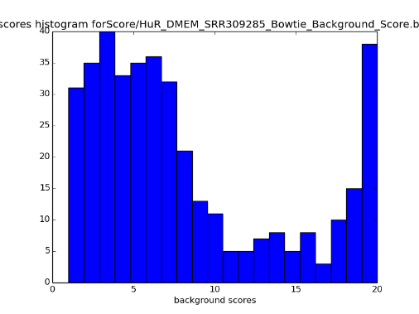 | 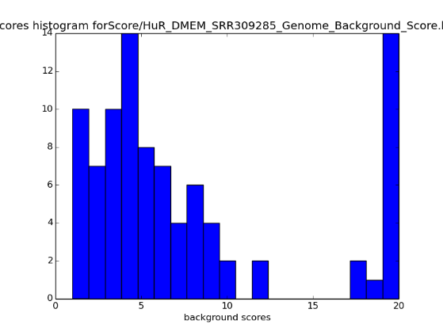
SRR309286 | 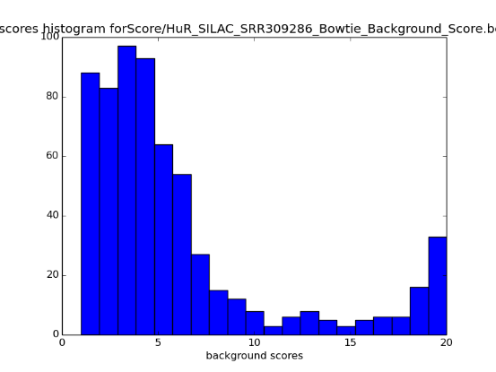 | 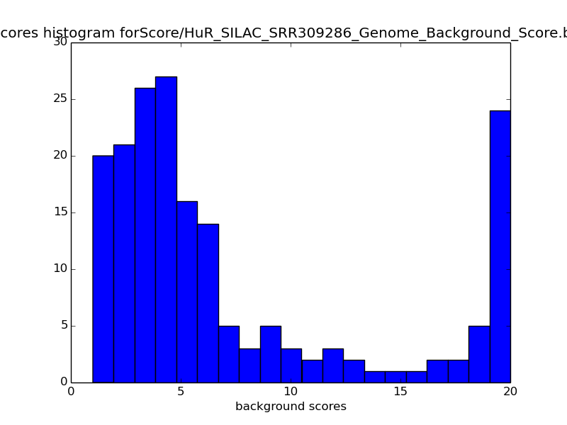

The distribution of the scores (Fig S10 and Fig S11) shown that the datasets have negligible presence of the common background.

4.5. YTH (YTH domain-containing protein 1)

There are five proteins (YTHDF1–3, YTHDC1 and YTHDC2) that contain the YTH domain in human cell (Stoilov et al., 2002; Xu et al., 2014). For YTH protein, two datasets (Table S8) were indexed in GEO bank. The motif GGAC was quantified in all clusters. However for YTH, we do not report results using Tophat because of format incompatibilities. The distribution of the scores is shown in figure S12.
Table S8: Background Quantification for protein

Table S8: Background Quantification for protein YTH

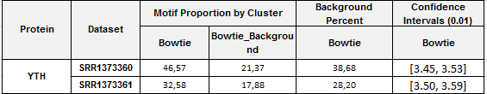

Figure S12: Histogram for scores in the intersection between the common background and two YTH PAR-CLIP datasets (aligned with Bowtie)

 | Bowtie
SRR1373360 | 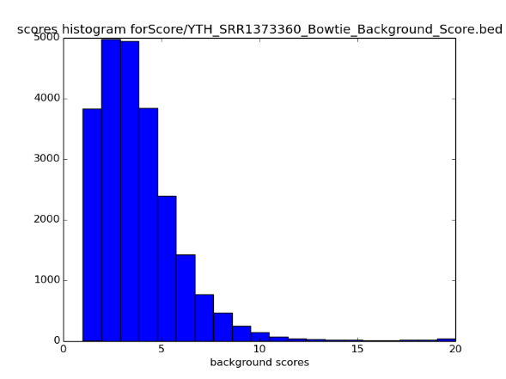
SRR1373361 | 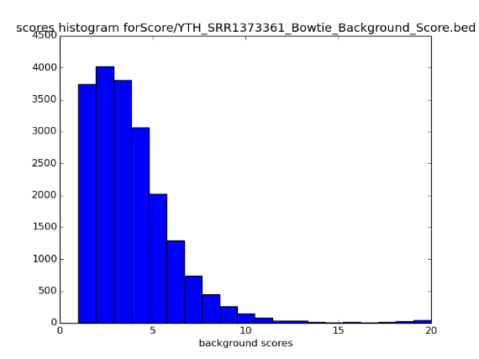

These Datasets present a low amount of common background for both replicates.

4.6. AUF1 (Heterogeneous nuclear ribonucleoprotein D0)

AUF1 has high affinity for RNA molecules that contain AU-rich elements (AREs) found within the 3'UTR of many genes. (Yoon et al., 2014; Wagner et al., 1998). We analyzed four AUF1 datasets (Table S9).
Table S9: Background Quantification for protein.

Table S9: Background Quantification for protein AUF1

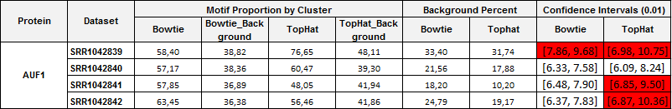

Figure S13: Boxplot for the scores in the intersection between the common background and four AUF1 PAR-CLIP datasets.
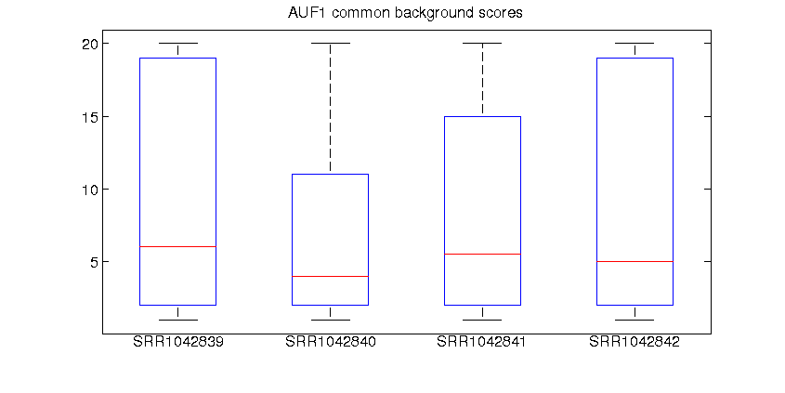

Figure S14: Histogram for scores in the intersection between the common background and four AUF1 PAR-CLIP datasets (aligned with Bowtie and Tophat)

 | Bowtie | Tophat
SRR1042839 | 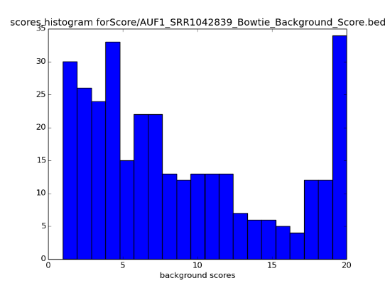 | 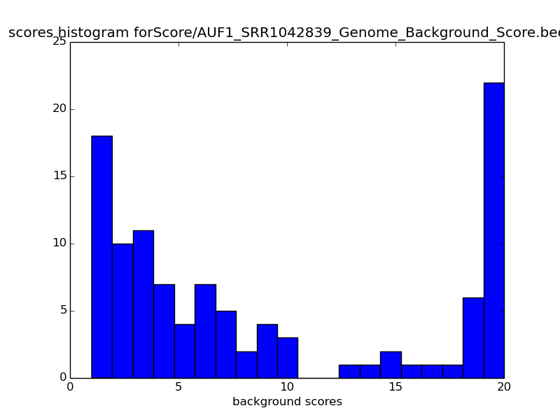
SRR1042840 | 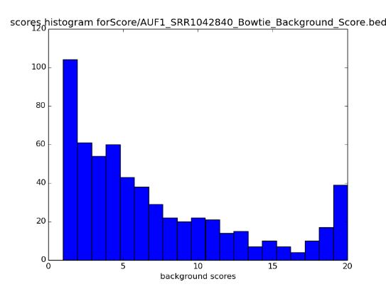 | 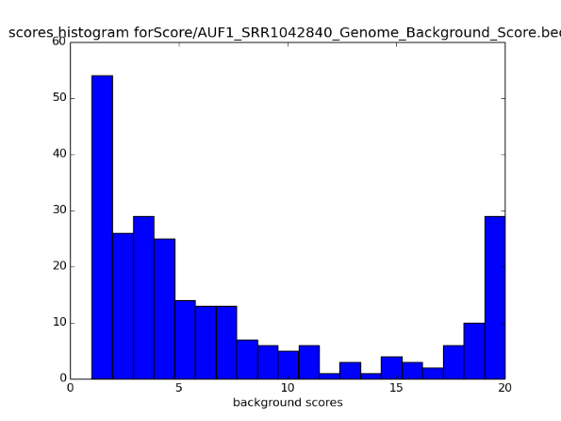
SRR1042841 | 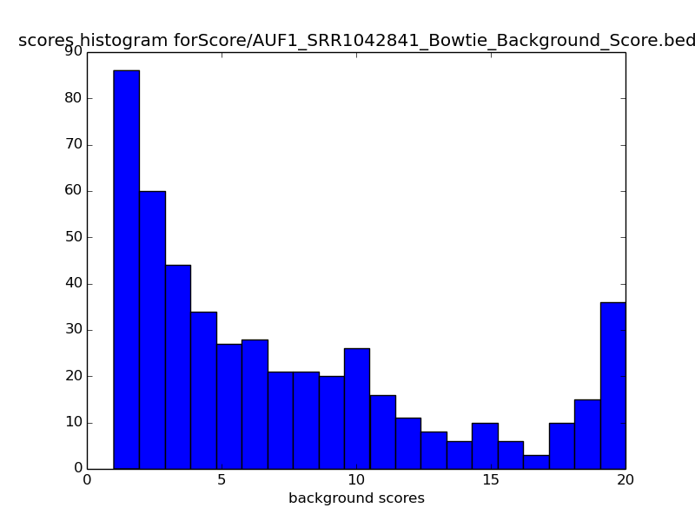 | 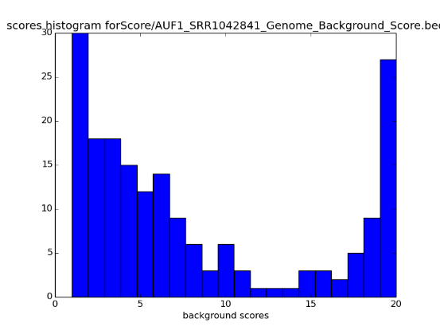
SRR1042842 | 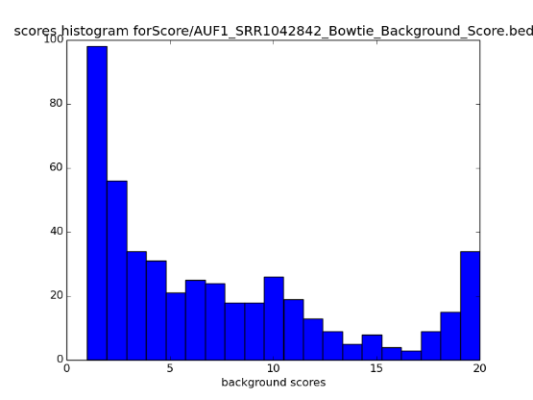 | 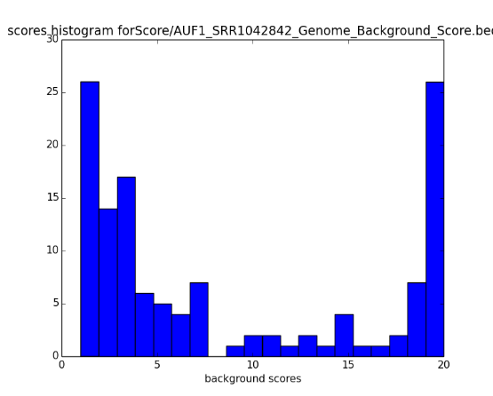

The distribution of the score (Fig S3) shown a significant amount of noise in two datasets SRR1042839 and SRR1042842

4.7. MOV10 (Putative helicase MOV-10)

MOV10 participates in RNA-mediated gene silencing by the RNA-induced silencing complex (RISC). Also, MOV10 is necessary to mRNAs processing by RISC (Sievers et al., 2012). For this protein, we used one dataset SRR490650 (Table S10).

Table S10: Background Quantification for protein MOV10
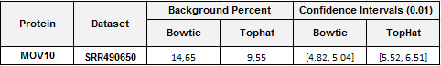

Figure S15: Histogram for scores in the intersection between the common background and one MOV10 PAR-CLIP datasets (aligned with Bowtie and Tophat)

 | Bowtie | Tophat
SRR490650 | 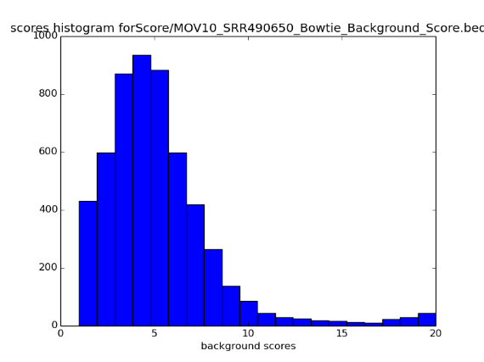 | 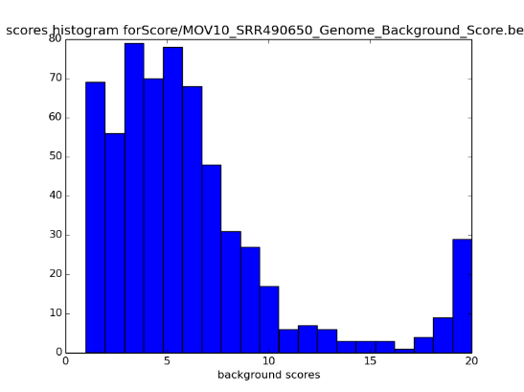

The dataset has a negligible amount of common background.

4.8. CF_Im25 (Cleavage and polyadenylation specificity factor subunit 5)

CF_lm25 belongs to the cleavage factor Im (CFIm) complex; it is important to pre-mRNA 3'processing. (Martin et al., 2012). Two datasets were analyzed (Table S11).

Table S11: Background Quantification for protein MOV10
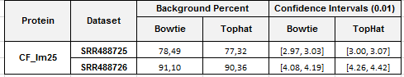

Figure S17: Histogram for scores in the intersection between the common background and two CF_lm25 PAR-CLIP datasets (aligned with Bowtie and Tophat)
 | Bowtie | Tophat
SRR488725 | 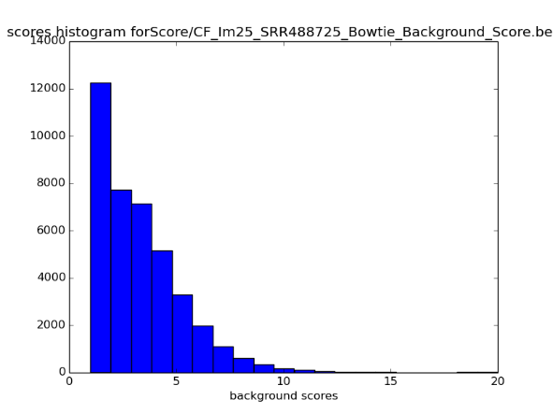 | 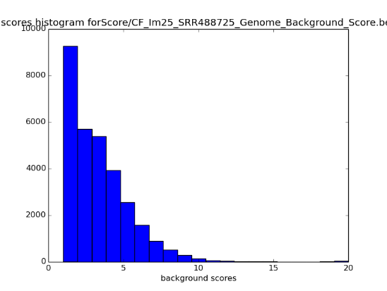
SRR488726 | 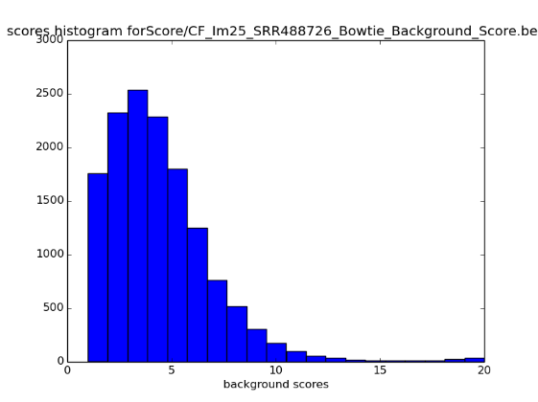 | 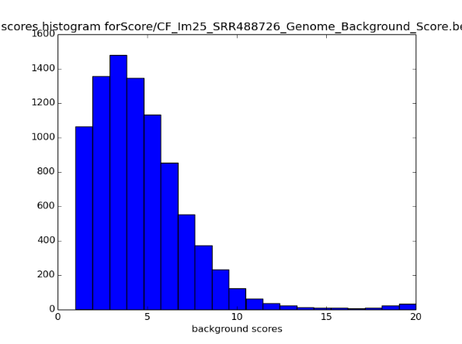

The score distribution showed that these datasets have a negligible amount of common background.

  - QKI Quaking

Table S 12. Number of motifs in the intersection with the common background divided by the score.
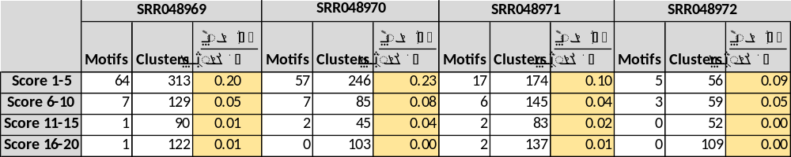

Table s13. 25,50,75,100 percentile for the distributions of the dataset vs the intersection (dataset and the common background)
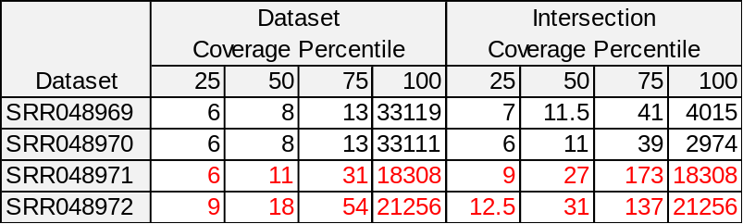

- References

Ascano,M. et al. (2012) FMRP targets distinct mRNA sequence elements to regulate protein expression. Nature, 492, 382–6.
Baltz,A.G. et al. (2012) The mRNA-bound proteome and its global occupancy profile on protein-coding transcripts. Mol. Cell, 46, 674–90.
Corcoran, D., Georgiev, S., Mukherjee, N., Gottwein, E., Skalsky, R., Keene, J., Ohler, U. (2010) PARalyzer: definition of RNA binding sites from PAR-CLIP short-read sequence data. Genome Biology, 12:R79
Dale, R. K., Pedersen, B. S., Quinlan, A. R. (2011). Pybedtools: a flexible python library for manipulating genomic datasets and annotations. Bioinformatics, 27(24), 3423–4.
Friedersdorf,M.B. and Keene,J.D. (2014) Advancing the functional utility of PAR-CLIP by quantifying background binding to mRNAs and lncRNAs. Genome Biol., 15, R2.
Hafner,M. et al. (2010) Transcriptome-wide identification of RNA-binding protein and microRNA target sites by PAR-CLIP. Cell, 141, 129–41.
Kishore,S. et al. (2011) A quantitative analysis of CLIP methods for identifying binding sites of RNA-binding proteins. Nat. Methods, 8, 559–64.
Langmead,B. et al. (2009) Ultrafast and memory-efficient alignment of short DNA sequences to the human genome. Genome Biol., 10, R25.
Lebedeva,S. et al. (2011) Transcriptome-wide analysis of regulatory interactions of the RNA-binding protein HuR. Mol. Cell, 43, 340–52.
Ma,W.J. et al. (1996) Cloning and characterization of HuR, a ubiquitously expressed Elav-like protein. J. Biol. Chem., 271, 8144–51.
Martin,G. et al. (2012) Genome-wide analysis of pre-mRNA 3’ end processing reveals a decisive role of human cleavage factor I in the regulation of 3' UTR length. Cell Rep., 1, 753–63.
Moore,F.L. et al. (2003) Human Pumilio-2 is expressed in embryonic stem cells and germ cells and interacts with DAZ (Deleted in AZoospermia) and DAZ-like proteins. Proc. Natl. Acad. Sci. U. S. A., 100, 538–43.
Nielsen,J. et al. (1999) A family of insulin-like growth factor II mRNA-binding proteins represses translation in late development. Mol. Cell. Biol., 19, 1262–70.
Quinlan,A.R. and Hall,I.M. (2010) BEDTools: a flexible suite of utilities for comparing genomic features. Bioinformatics, 26, 841–2.
Sievers,C. et al. (2012) Mixture models and wavelet transforms reveal high confidence RNA-protein interaction sites in MOV10 PAR-CLIP data. Nucleic Acids Res., 40, e160.
Skalsky,R.L. et al. (2012) The viral and cellular microRNA targetome in lymphoblastoid cell lines. PLoS Pathog., 8, e1002484.
Stoilov,P. et al. (2002) YTH: a new domain in nuclear proteins. Trends Biochem. Sci., 27, 495–7.
Trapnell,C. et al. (2009) TopHat: discovering splice junctions with RNA-Seq. Bioinformatics, 25, 1105–11.
Wagner,B.J. et al. (1998) Structure and genomic organization of the human AUF1 gene: alternative pre-mRNA splicing generates four protein isoforms. Genomics, 48, 195–202.For
Xu,C. et al. (2014) Structural basis for selective binding of m6A RNA by the YTHDC1 YTH domain. Nat. Chem. Biol., 10, 927–9.
Yoon,J.-H. et al. (2014) PAR-CLIP analysis uncovers AUF1 impact on target RNA fate and genome integrity. Nat. Commun., 5, 5248.

